St. Joseph’s Catholic Church Oatley

PO Box 105 (21C Frederick Street) Oatley 2223

Rev. Paul Hilder – Parish Priest

Mrs. Nancy Miletic – Operations Manager (Tues & Wed)

‘Phone 9580 1864, Email: [oatleycc@bigpond.net.au](mailto:oatleycc@bigpond.net.au)

Parish website: [www.stjosephschurch.com.au](http://www.stjosephschurch.com.au)

St. Joseph’s Catholic Primary School, Oatley

Mrs Kylie Brakel – Principal. ‘Phone 9580 6588

St. Joseph’s Mass Times

**Saturday Vigil**: 5.00 pm **Sunday:** 8 am and 10 am

**Weekday Masses**: at 8 am on Monday, Tuesday, Wednesday, Friday & Saturday

**Thursday:** Exposition of the Blessed Sacrament and Benediction from 11 am and

Mass at 12 md

**Public Holidays:** 9 am only

**Confessions are available before the 5 pm Vigil Mass (4 pm to 4.45 pm)**

20th June 2021 – Twelfth Sunday in Ordinary Time

**THE POWER OF GOD:** The great Saint Teresa of Avila said, “You must realise that in the spiritual world as in this world, there are different kinds of weather.” Tempest can beat against both the body and spirit of a person, and in the face of these we need the peace and strength arising from confidence in the power of God. Poor Job, sitting on his ash-heap, beaten to the ground by suffering, both physical and mental, and near to breaking-point could say *The Lord has given and the Lord has taken away; Blessed be the name of the Lord.* At the same time, he *cursed the day he was born.*  But God, knowing his good will, came to his help. He speaks of the wonders of his mighty works amid a raging tempest. He is saying to Job in effect, *I am only putting you to the test. I, who created the tempest and the very sea itself, can easily relieve you of all your pains. Trust in me is all I ask.*

In the Gospel we read of another storm with God-made man speaking through the howling of the wind to frightened men. Again, it is the lesson of confidence that he gives them. He displays his power before their eyes. He speaks to the raging wind and waves as though they were naughty children telling them to be still *and all was calm again.*

If only we could bring home to ourselves the almighty power of God which after all, is only a facet of his love, we would sail much more calmly through the troubled waters of life. This love of God is about us and is in us all day long, but we so easily forget it and become caught up in our trivial pains and difficulties. We should pray with the psalmist, *God is my refuge and strength,* and in such a prayer made with confidence, though it will not dispel the trials of life, will give us great courage to face up to them. God knows our frame; he knows that we are but dust. He knows therefore that we need him. It is for us to realise that we can do nothing without him.

**Masses for the Deceased:** Brian Rayment, Peter Rayment, Walter Ryan,recently deceased. Tony Attard, Catherine Mary Fowler, Robert Holt and Maureen Stevens, anniversaries.

**The Parish now has the facility to stream our Sunday Masses:** You can access this on YouTube by following this link:

[bit.ly/stjoatley](http://bit.ly/stjoatley) or

.



**You can also access it by going to the Archdiocese of Sydney website where there is a list of Churches who stream their Masses each week. Just click on the link for St. Joseph’s Parish, Oatley.**

**Congratulations and thank you**

**Congratulations to all the children who made their first holy Communion this week, and to their parents. We thank especially Mrs Sandra Green, our Sacramental Coordinator, and all the parent and catechist helpers, who prepared the children for this important milestone in their journey of faith.**

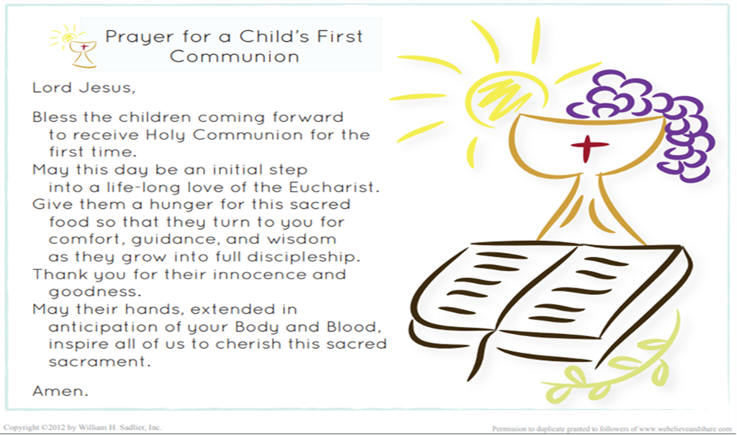

Sacramental Program for 2021: Please visit the Parish website: www.stjosephschurch.com.au

**Imposition of restrictions concerning Churches**: From Friday, 12th February, an unlimited number of people can attend Mass, provided that the one person per 2 metre square rule is observed. However, our Church will only hold at least eighty according to this regulation, any overflow would have to be accommodated in the Marion Hall where the Mass can be viewed on the TV monitor. Because of the easing of the restrictions, the Archbishop has lifted the dispensation from our Sunday Mass obligation. ***Parishioners are once again obliged******to attend Mass on Sundays and Holy Days of obligation when this is reasonably*** ***possible.*** Those of great age, have health conditions or are otherwise anxious about the risks of Covid19 are free to remain at home and find another way of keeping the Sabbath holy.

There is still the requirement of taking names and contact details of attendees. The use of a QR code is recommended for those with iPhones or smart phones. The NSW Services app would need to be install on your phone to access the code. The first time you use the code, it will ask you to provide your name and contact number. It will then send you a code to enter with your details and the app will then be active. It is then used every time you attend Mass, or when and where you visit other venues that have a QR code registration system in place.

The wearing of masks is no longer mandatory, but strongly recommended where social distancing is not possible.

Parishioners who elect to attend Mass during the pandemic should consider the safety of other parishioners by staying away if they are unwell, and if so, getting tested and self-isolating while awaiting the results. It is also advisable that parishioners only attend Mass in their own parish and not move from parish to parish.



***PLANNED GIVING: Your contribution to the 2nd collection goes towards the running and upkeep of our parish, and 30% of what you donate is eligible for a tax deduction.***

New Contributors: Please fill in the planned giving form, which can be accessed on the website under DONATIONS, if you wish to become part of our regularly giving programme at St Joseph’s Parish Oatley. Otherwise, you may obtain the form from the church foyer or contact the parish office.

Please put your completed form in the second collection, otherwise email it to oatleycc@bigpond.net.au or drop it in to the Parish Office. Alternatively, you can post it to: St Joseph’s Parish, 21C Frederick St, Oatley NSW 2223.

If you wish to donate to the Church Account (Second Collection) there is a Bpoint facility on this website under “Donations” on the menu. Please follow the links. If you do not wish to make an internet or online payment, please email the Office [oatleycc@bigpond.net.au](mailto:oatleycc@bigpond.net.au) or contact 9580 1864.

***Thank you for contributing to St. Joseph’s Parish. I am very appreciative of your ongoing generosity and commitment to support our Parish in achieving its Pastoral Mission and meeting ongoing expenses. Fr. Paul.***

**20th June 2021 – Twelfth Sunday in Ordinary Time**

**THE INTRODUCTORY RITES**

**Entrance Procession**

***The Lord is the strength of his people,***

***a saving refuge for the one he has anointed.***

***Save your people, Lord, and bless your heritage,***

***and govern them for ever.***

**Penitential Act**

I confess to almighty God

and to you, my brothers and sisters,

that I have greatly sinned,

in my thoughts and in my words,

in what I have done and in what I have failed to do,

through my fault, through my fault,

through my most grievous fault;

therefore I ask blessed Mary ever-Virgin,

all the Angels and Saints,

and you, my brothers and sisters,

to pray for me to the Lord our God.

May almighty God have mercy on us, forgive us our sins,

and bring us to everlasting life.

Amen.

Lord, have mercy.  **Lord, have mercy.**

Christ, have mercy. **Christ, have mercy.**

Lord, have mercy. **Lord, have mercy.**

**Gloria**

Glory to God in the highest,

and on earth peace to people of good will.

We praise you,

we bless you,

we adore you,

we glorify you,

we give you thanks for your great glory,

Lord God, heavenly King,

O God, almighty Father.

Lord Jesus Christ, Only Begotten Son,

Lord God, Lamb of God, Son of the Father,

you take away the sins of the world,

have mercy on us;

you take away the sins of the world,

receive our prayer;

you are seated at the right hand of the Father,

have mercy on us.

For you alone are the Holy One,

you alone are the Lord,

you alone are the Most High,

Jesus Christ,

with the Holy Spirit,

in the glory of God the Father.

Amen.

**Collect**

Let us pray.

Grant, O Lord,

that we may always revere and love your holy name,

for you never deprive of your guidance

those you set firm on the foundation of your love.

Through our Lord Jesus Christ, your Son,

who lives and reigns with you in the unity of the Holy Spirit,

God, for ever and ever.

Amen.

**THE LITURGY OF THE WORD** (Refer to your Sunday Missal or Liturgy Sheet)

**PROFESSION OF FAITH (Nicene Creed)**

I believe in one God,

the Father almighty,

maker of heaven and earth,

of all things visible and invisible. I believe in one Lord Jesus Christ,

the Only Begotten Son of God,

born of the Father before all ages.

God from God, Light from Light,

true God from true God,

begotten, not made, consubstantial with the Father;

through him all things were made.

For us men and for our salvation

he came down from heaven,

At the words that follow, up to and including 'and became man', all bow.

and by the Holy Spirit was incarnate of the Virgin Mary,

and became man. For our sake he was crucified under Pontius Pilate,

he suffered death and was buried,

and rose again on the third day

in accordance with the Scriptures.

He ascended into heaven

and is seated at the right hand of the Father.

He will come again in glory

to judge the living and the dead

and his kingdom will have no end.

I believe in the Holy Spirit, the Lord, the giver of life,

who proceeds from the Father and the Son,

who with the Father and the Son is adored and glorified,

who has spoken through the prophets.

I believe in one, holy, catholic and apostolic Church.

I confess one Baptism for the forgiveness of sins

and I look forward to the resurrection of the dead

and the life of the world to come. Amen.

**GENERAL INTECESSIONS FOR THE TWELFTH SUNDAY OF ORDINARY TIME.**

***My dear brothers and sisters in Christ, let us offer our prayers on behalf of all, to the God whose mighty power earth and heaven obey.***

1. That Christians who have grown fearful or discouraged may have faith in the Teacher who will not permit us to perish. *Let us pray to the Lord.*
2. That nations battered by raging storms of violent conflict may come one day to rejoice again in the calm of peace. *Let us pray to the Lord.*
3. That those whose livelihood depends on the sea may prosper in their labours and be preserved from danger. *Let us pray to the Lord.*
4. That young people growing up in an unstable, turbulent and confusing world may find meaning in their lives and be helped to overcome failure. *Let us pray to the Lord.*
5. That the elderly, the sick and those who suffer poor health may experience the Lord’s loving kindness, comforting presence, and healing peace. *Let us pray to the Lord.*
6. That we who are blest to have Jesus present in our midst may be filled with awe for Our Teacher and love for each other. *Let us pray to the Lord.*
7. That those who have crossed with Jesus from this life to the other side may become a new creation in Christ for all eternity. *Let us pray to the Lord.*
8. For greater devotion to the Holy Mother of God, Star of the Sea and Comfort of the Afflicted. **HAIL MARY.**

***Lord God, write your words and commands on our hearts and lead us forward in the ways of love and peace. We ask this through Christ our Lord. AMEN.***

**Pope Francis Prayer for protection from Coronavirus**

O Mary, you shine continuously on our journey as a sign of salvation and hope. We entrust ourselves to you. Health of the sick. At the foot of the Cross you participated in Jesus’ pain, with steadfast faith. You, our Salvation, know what we need. We are certain that you will provide, so that, as you did at Cana of Galilee, joy and feasting might return after this moment of trial. Help us, Mother of Divine Love, to conform ourselves to the Father’s will and to do what Jesus tells us: He who took our sufferings upon Himself, and bore our sorrows to bring us, through the Cross, to the Joy of the Resurrection. Amen.

We seek refuge under your protection, O Holy Mother of God. Do not despise our pleas – we who are put to the test – and deliver us from every danger, O glorious and blessed Virgin.

**Our Spiritual Communion**

***My Jesus, I believe that you are present in the most Blessed Sacrament. I love You above all things and I desire to receive You into my soul. Since I cannot now receive you sacramentally, come at least spiritually into my heart. I embrace You as if You have already come and unite myself wholly to You. Never permit me to be separated from You. Amen.***

Our Father, Hail Mary, Glory be *etc.*

**Communion Antiphon**

***The eyes of all look to you, Lord,***

***and you give them their food in due season.***

**Prayer after Communion**

Let us pray.

Renewed and nourished

by the Sacred Body and Precious Blood of your Son,

we ask of your mercy, O Lord,

that what we celebrate with constant devotion

may be our sure pledge of redemption.

Through Christ our Lord.

Amen.

**BLESSING**

May the Lord bless us and keep us

May he let his face shine upon us

and show us his mercy.

May he turn his countenance towards us

and give us his peace.

And may Almighty God bless us all, in the name of the Father, and of Son and of the Holy Spirit. Amen.

***Let us praise the Lord and glorify him in our lives.*** Thanks be to God.